PRACTICAL -01
Aim:
To write a Python program to implement Bubble Sort, Selection Sort, Insertion Sort, Merge Sort, and Quick Sort algorithms, and analyze their execution time.
Theory:
Sorting algorithms arrange elements of an array in a particular order (ascending/descending). They differ in approach, efficiency, and time complexity:
Bubble Sort: Repeatedly compares adjacent elements and swaps them if they are inthe wrong order. The largest element &quot;bubbles up&quot; to the end in each pass. Timecomplexity: O(n²) in worst/average case.
Selection Sort: Repeatedly selects the minimum element from the unsorted part of the array and places it at the beginning. Time complexity: O(n²) in all cases.
Insertion Sort: Builds the sorted array one element at a time by inserting each element into its correct position among the previously sorted elements. Time complexity: O(n²) worst case, but efficient (O(n)) for nearly sorted data.
Merge Sort: A divide-and-conquer algorithm that recursively splits the array into halves, sorts each half, and merges them back together. Time complexity: O(n log n) in all cases, but requires O(n) extra space.
Quick Sort: A divide-and-conquer algorithm that selects a pivot element, partitions the array so smaller elements go left and larger go right, then recursively sorts each partition. Average time complexity: O(n log n); worst case O(n²), though this is rare with a good pivot choice.
Comparing execution times shows that Merge Sort and Quick Sort significantly outperform the O(n²) algorithms (Bubble, Selection, Insertion) as the size of the input array grows.
Algorithm:
- Input the array of elements.
- Create separate copies of the array for each sorting algorithm (since sorting modifies the array in place).
- Bubble Sort: For each pass i from 0 to n-1, compare adjacent elements arr[j] and arr[j+1]; swap if arr[j] > arr[j+1].

- Selection Sort: For each position i from 0 to n-1, find the index of the minimum element in the unsorted part (i to n-1) and swap it with arr[i].
- Insertion Sort: For each element from index 1 to n-1, shift larger elements in the sorted part one position right and insert the current element in its correct position.
- Merge Sort: Recursively divide the array into two halves until each sub-array has one element; then merge sub-arrays back in sorted order.
- Quick Sort: Choose a pivot; partition array elements around the pivot; recursively apply quick sort to the sub-arrays before and after the pivot.
- Record the start and end time around each sorting call to calculate the time taken.
- Display the sorted array and the time taken by each algorithm.
- Compare the execution times of all five algorithms.

Program Code:
# 1. BUBBLE SORT
def bubble_sort(arr):
n = len(arr)
for i in range(n - 1):
swapped = False
for j in range(n - 1 - i):
if arr[j] > arr[j + 1]:
arr[j], arr[j + 1] = arr[j + 1], arr[j]
swapped = True
if not swapped: # already sorted, stop early
break
return arr

# 2. SELECTION SORT
def selection_sort(arr):
n = len(arr)
for i in range(n - 1):
min_idx = i
for j in range(i + 1, n):
if arr[j] < arr[min_idx]:
min_idx = j
arr[i], arr[min_idx] = arr[min_idx], arr[i]
return arr
# 3. INSERTION SORT
def insertion_sort(arr):
for i in range(1, len(arr)):
key = arr[i]
j = i - 1
while j >= 0 and arr[j] > key:
arr[j + 1] = arr[j]
j -= 1
arr[j + 1] = key
return arr
# 4. MERGE SORT
def merge_sort(arr):
if len(arr) <= 1:
return arr
mid = len(arr) // 2
left = merge_sort(arr[:mid])
right = merge_sort(arr[mid:])
return _merge(left, right)
def _merge(left, right):
result = []
i = j = 0
while i < len(left) and j < len(right):
if left[i] <= right[j]:
result.append(left[i])
i += 1
else:
result.append(right[j])
j += 1
result.extend(left[i:])
result.extend(right[j:])
return result

# 5. QUICK SORT
def quick_sort(arr, low=0, high=None):
if high is None:
high = len(arr) - 1

if low < high:
pivot_index = _partition(arr, low, high)
quick_sort(arr, low, pivot_index - 1)
quick_sort(arr, pivot_index + 1, high)
return arr

def _partition(arr, low, high):
pivot = arr[high] # choosing last element as pivot
i = low - 1
for j in range(low, high):
if arr[j] <= pivot:
i += 1
arr[i], arr[j] = arr[j], arr[i]
arr[i + 1], arr[high] = arr[high], arr[i + 1]
return i + 1

# DEMO / TEST

if __name__ == "__main__":
test_data = [12, 20, 10, 6, 9, 11, 7, 8 ]

print("Original array: ", test_data)
print("Bubble Sort: ", bubble_sort(test_data.copy()))
print("Selection Sort: ", selection_sort(test_data.copy()))
print("Insertion Sort: ", insertion_sort(test_data.copy()))
print("Merge Sort: ", merge_sort(test_data.copy()))
print("Quick Sort: ", quick_sort(test_data.copy()))

Output:
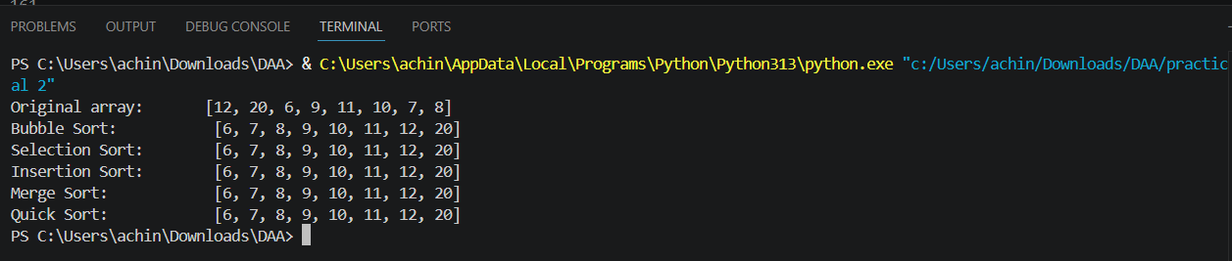
Result:
The program successfully implements Bubble Sort, Selection Sort, Insertion Sort, Merge Sort, and Quick Sort in Java, and their execution times are measured using System.nanoTime(). It is observed that for small input sizes, simpler algorithms like Insertion Sort and Quick Sort can perform comparably fast, but for larger datasets, Merge Sort and Quick Sort (O(n log n)) significantly outperform Bubble Sort, Selection Sort, and Insertion Sort (O(n²)).

